Abhishek Ojha

Seat No 027

pRACTICAL NO 2

Triggers

**Practical No 2**

**Aim:**

Place the replication of global conceptual schema on different nodes and execute queries that will demonstrate distributed databases environment.

**Software Requirement:**

Oracle 11g.

**Query:**

1. Update any record in db1 & show in db2

2. Delete any record in db1 & show in db2.

3. Find the salary of all employees.

4. Find the email of all employees where salary = 15000.

5. Find the employee name and email where employee number is known.

6. Find the employee name and address where employee number is known.

**Step 1:** Create Table in db1.

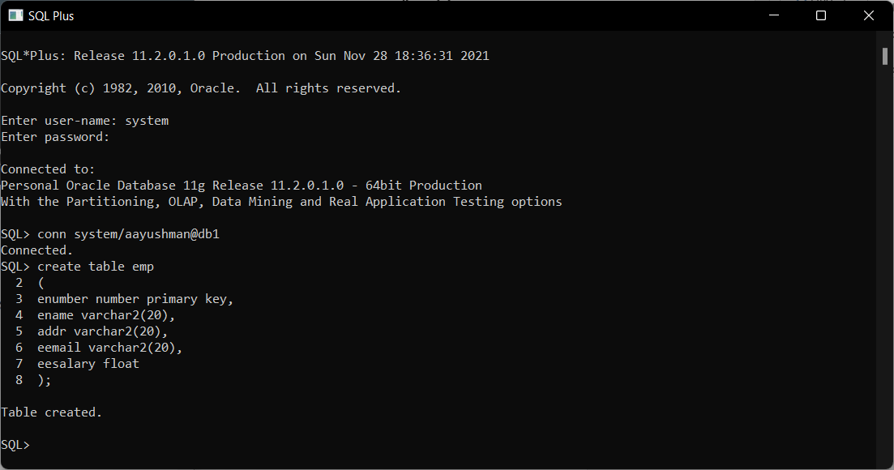

**Step 2:** Create Table in db2.

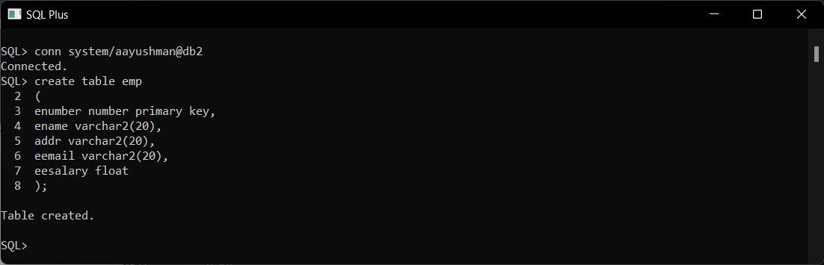

**Step 3:** Create Database link.

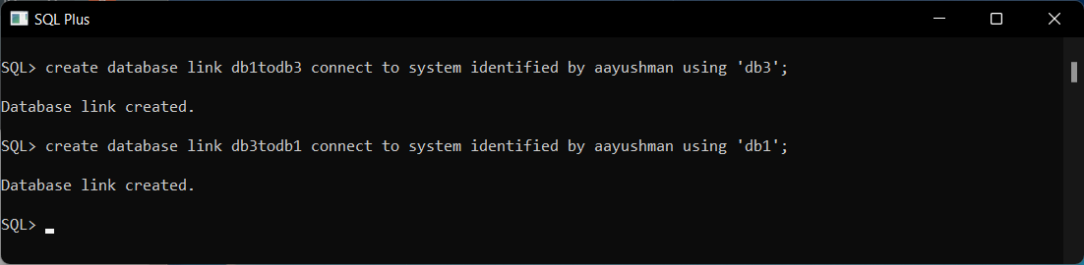

**Step 4:** Create Trigger to Insert Data.

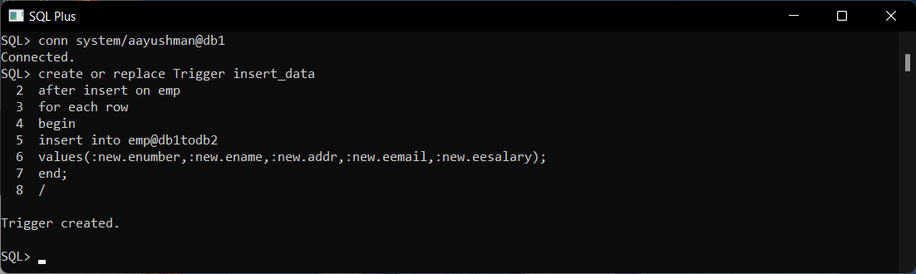

**Step 5:** Create Trigger to Update Data in Table.

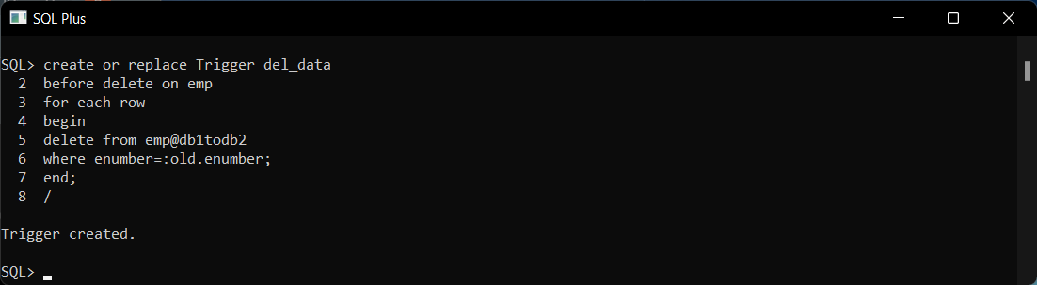

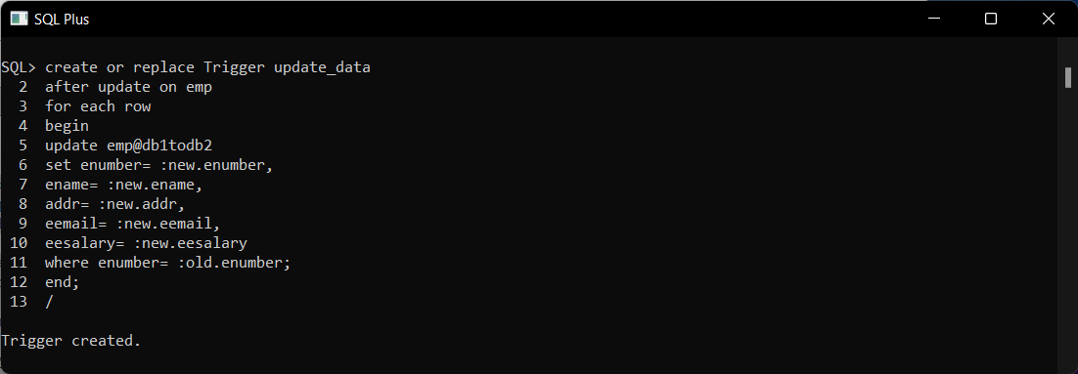

**Step 6:** Insert Values in Created Table.

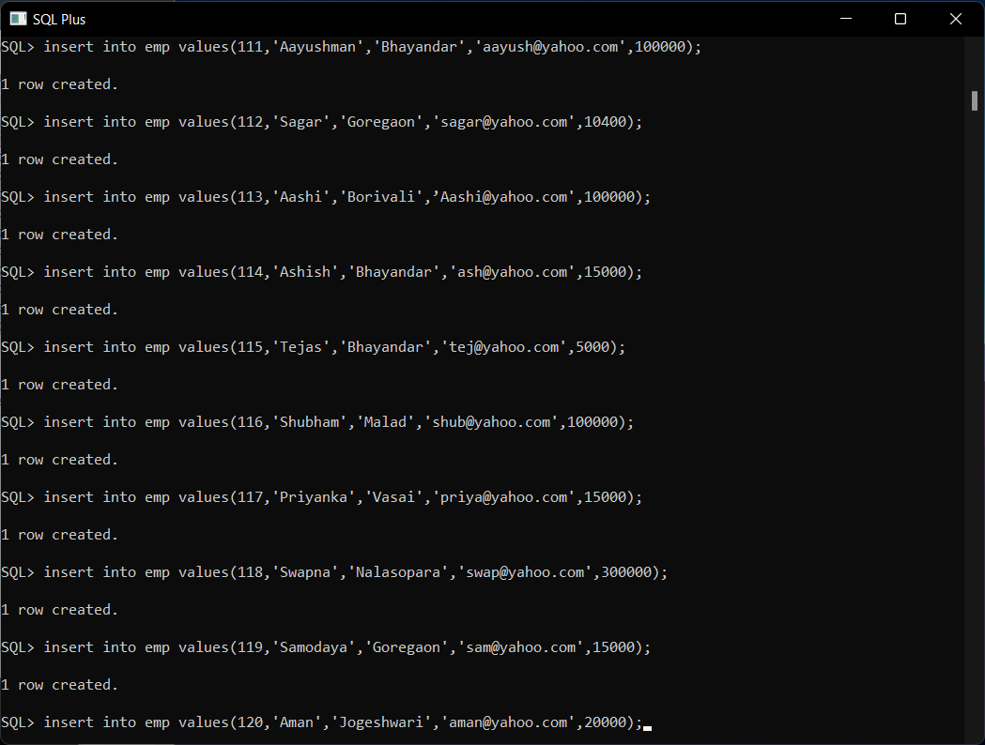

Show Create Tables.

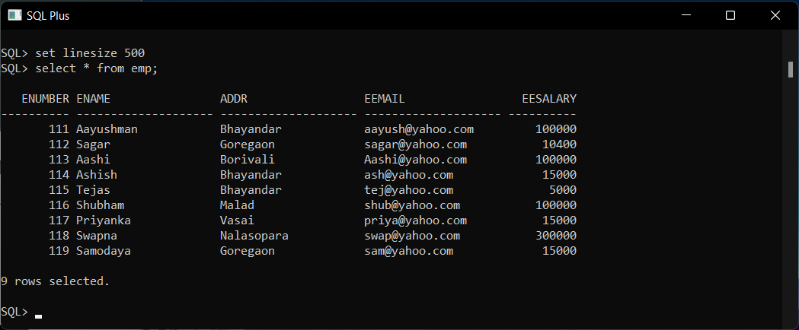

**Query**

1. **Update any record in db1 & show in db2.**

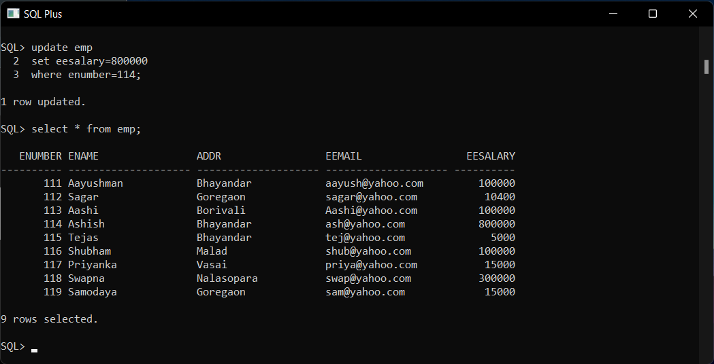

Show Updated Table in db2.

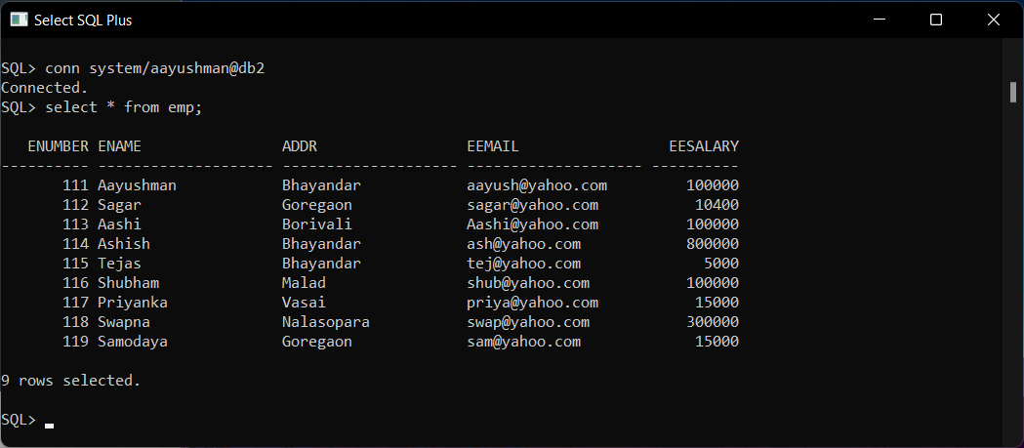

1. **Delete any record in db1 & show in db2.**

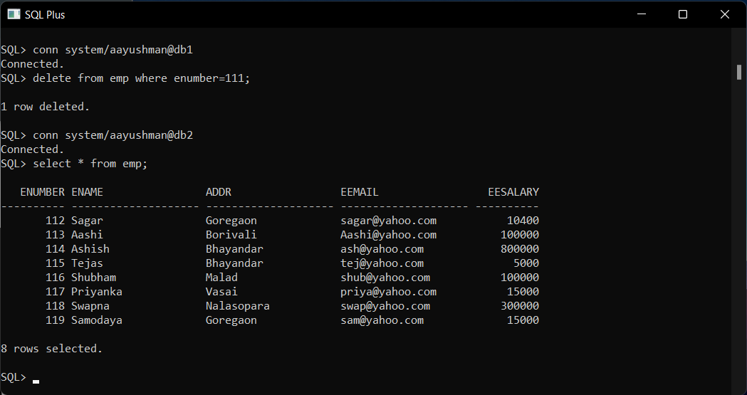

1. **Find the salary of all employees.**

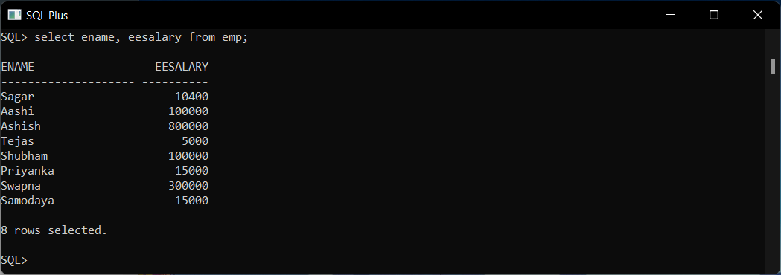

1. **Find the email of all employees where salary = 15000.**

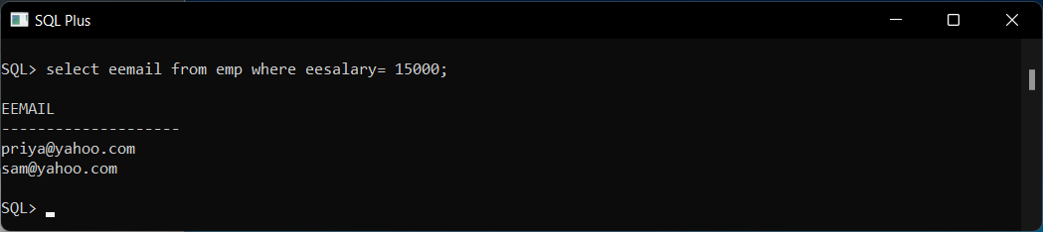

1. **Find the employee name and email where employee number is known.**

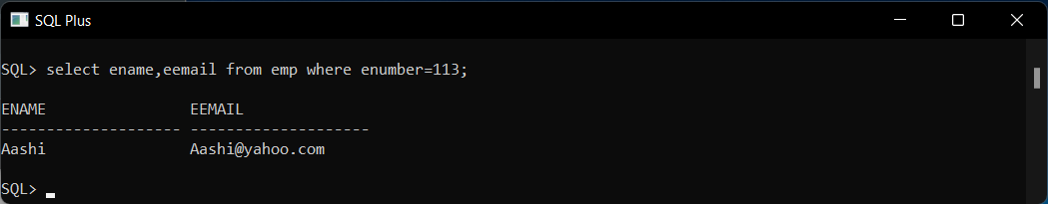

1. **Find the employee name and address where employee number is known.**

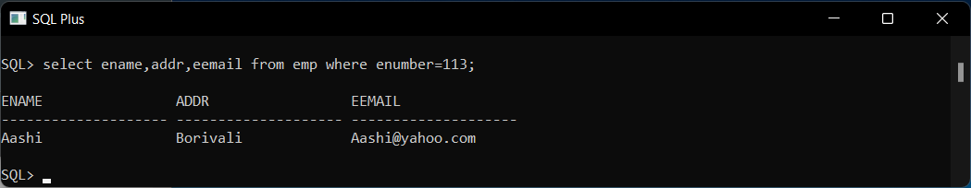

**Conclusion**: Successfully Created Triggers and Perform Different Queries on them.